Self-Hosted Git + Jenkins Hooks

For this we’ll be using Gitea (pronounced: “Git Tea” or “Gitty”)

I’m hosting it on an Arch Linux (EndeavourOS) server so I’ll simply get it from the AUR and run it. It runs off of localhost:3000 → the only change I’ve made to the default configuration is that I’ll be using sqliite3 as my database rather than postgres or mysql.

Now in Jenkins install the “Gitea” plugin.

From here we’re going to follow:

https://plugins.jenkins.io/gitea/

manage jenkins → configure system → Gitea Servers

Click “add” and name it whatever you want. In my case my server is hosted at “http://localhost:3000”. Apply and save.

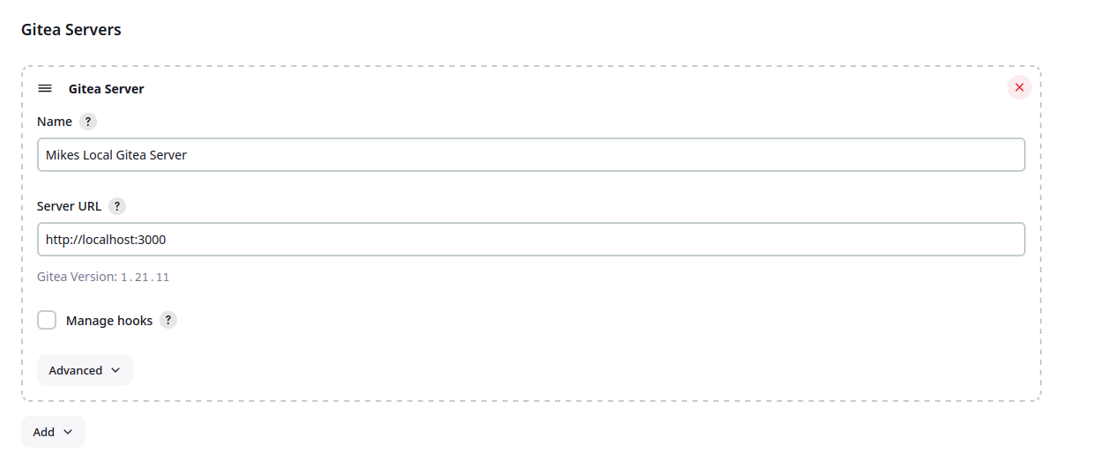

Log into your Gitea instance (localhost:3000) and create a new user named “jenkins” on the admin page.

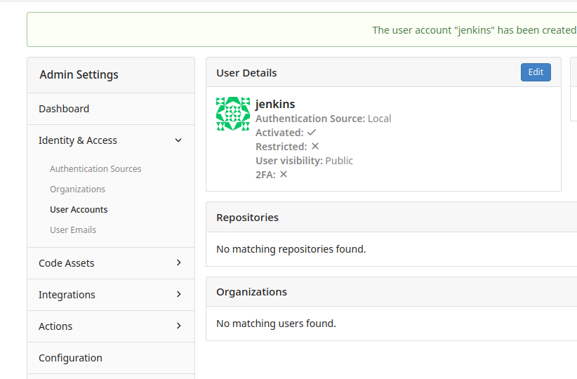
Create an org (“mikes-org”) and then add the jenkins user to that org. It’s a little confusing but it’s actually on the “teams” page:

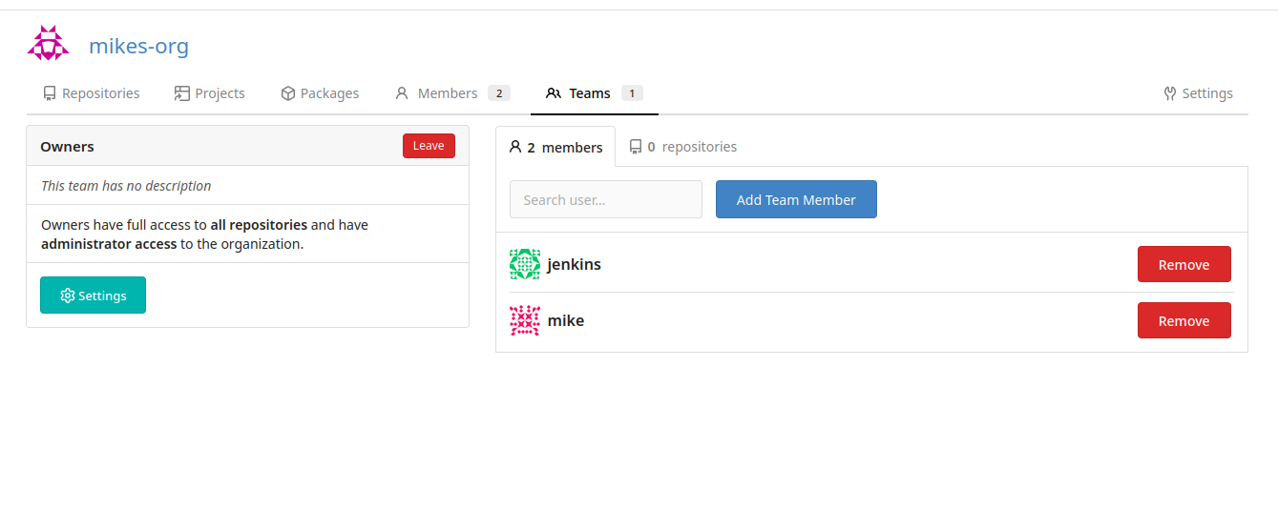

Afterwards, log out of the admin account and log into the jenkins account as we need to get a token.

Settings – application → add new access token

I’m not putting anything secure or interesting on here, so, here’s me breaking some rules and adding the token I made to this very document:

57174ef31baa399590d3ca39da92ca41099640b2
-I gave it all permissions.

Now I’ve had my admin user create a repo in the org that jenkins belongs to (“mikes-org”)

http://localhost:3000/mikes-org/jenkins-test-org

Now back over to jenkins

create item → item type is Oraganizational Folder

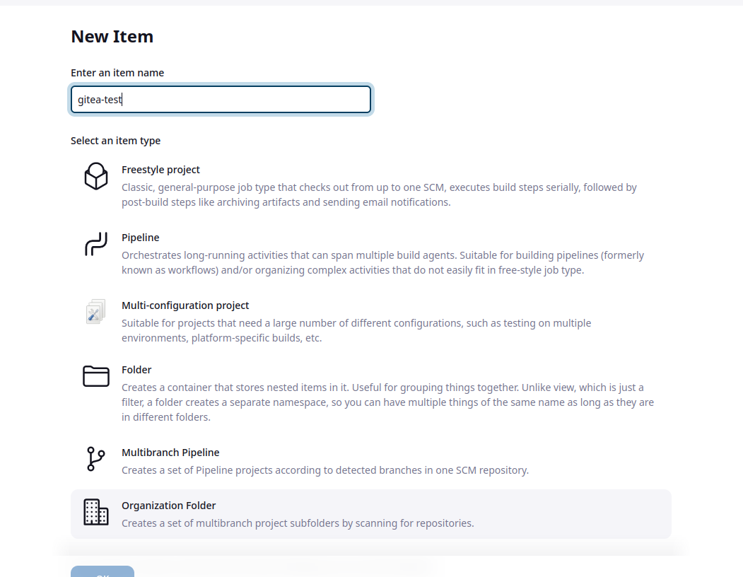

Now in configure go to repository sources

Add a Gitea Organization:

Add credentials of type “Gitea Access Token”

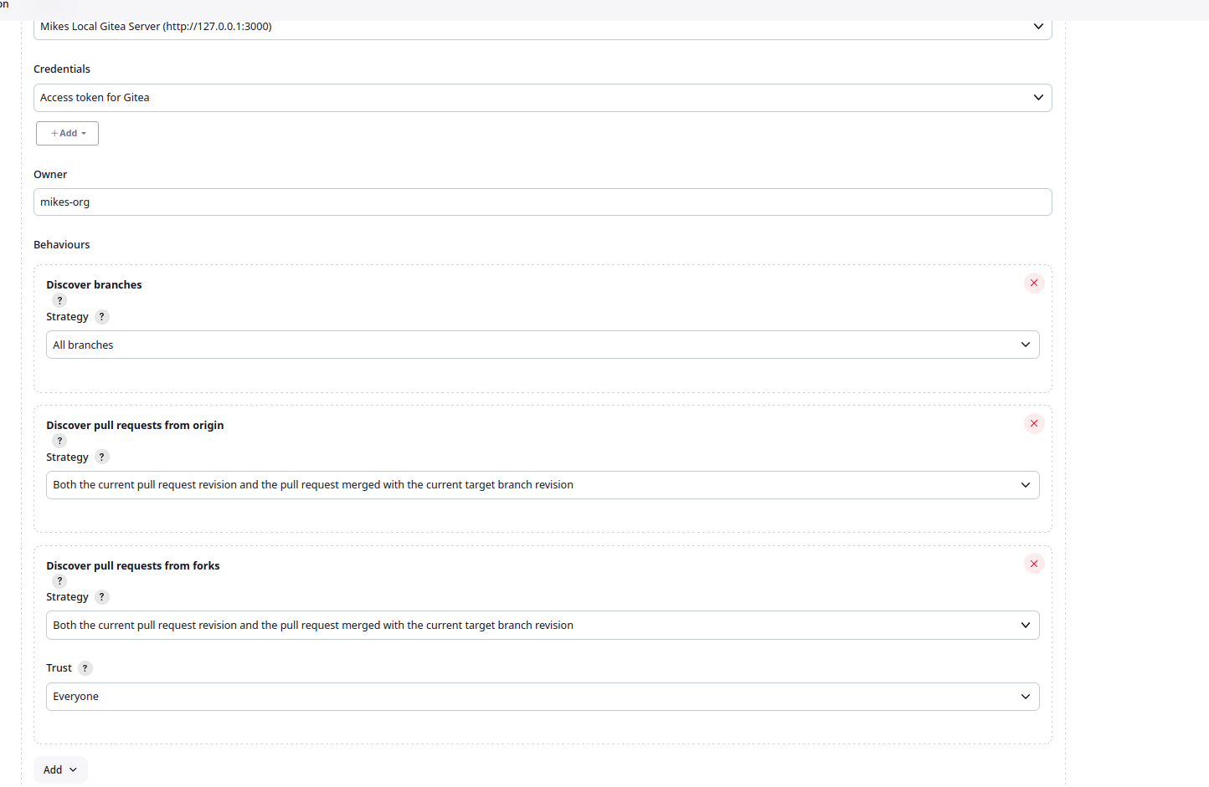

Here’s how I’ve set it up. I’m going to save it now. Note that the NAME OF THE ORG and the OWNER fields need to match the name of the org on Gitea and the Org we added the Gitea User “jenkins” to, in this case “mikes-org” for which the api token is paired.

Now scan orgs:

Hmmm… seeing some weird behavior. Gitea is not scanning from the org we created, but WILL scan things created under the jenkins user?

Woah! Okay the OWNER needs to be the ORG , not the jenkins user. Doh.

Now it scans and works!!!

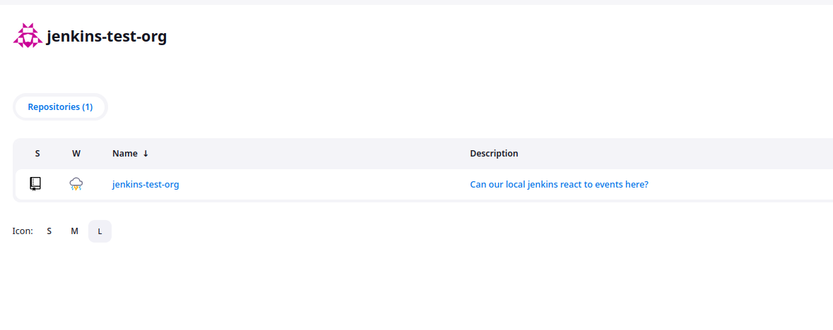
Can it build?!

